Lab 5: File System

Alex Arnold

2.4 - Hex window

2.10 - Highlight 16 bytes

3.5 - Highlight 16 bytes

3.11 - Hex window showing NTFS

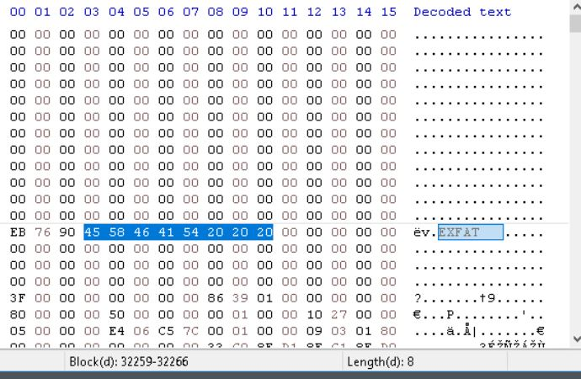

4.10 - Offset 32256 - Highlighting OEM ID